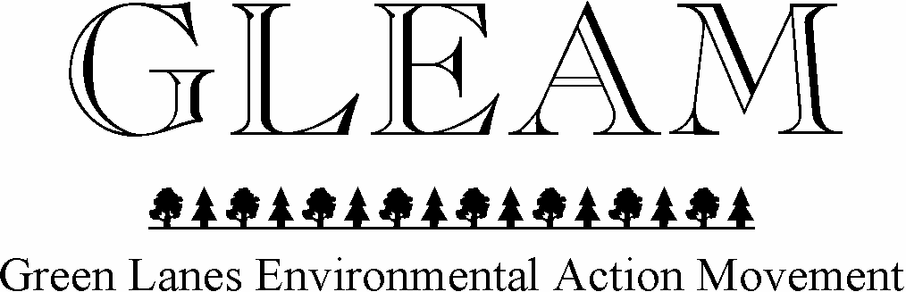

Patron: HRH The Duke of Edinburgh KG KT

23 August For immediate use

Battle to stop damaging ‘off-roading’ in Little Langdale will continue

The High Court has found against the Green Lanes Environmental Action Movement (GLEAM) in its Judicial Review of the Lake District National Park Authority (LDNPA). But this does not affect the validity of GLEAM’s central claim, that off-roading on two fell tracks near Little Langdale is environmentally and socially unacceptable. The request to ban off-roading on these routes is supported by residents, the National Trust, UNESCO, the Friends of the Lake District, the Ramblers, and three mountaineering clubs. GLEAM is therefore determined to continue the battle to protect these green lanes.

GLEAM says that, despite the High Court ruling, the rising level of damage to natural beauty, together with complaints from residents and the wider public, will eventually force the LDNPA to change its mind and that it is only a question of time before the LDNPA has to impose Traffic Regulation Orders (TROs) to stop motor bikes and 4x4s from using the two Little Langdale fell tracks that were at the heart of the Court action. Meanwhile GLEAM will be considering whether there are grounds for appeal against the High Court ruling.

Commenting on the judicial review case, GLEAM Chairman Dr Mike Bartholomew said:

‘It is important to be clear about exactly what the Court was considering. It was not deciding, and we did not ask it to decide, whether off-roading on the two tracks should or should not continue, nor whether there should be TROs on the two routes. What we asked the court to consider was whether the way in which the LDNPA made its decision not to use its TRO powers was lawful.

‘We are of course disappointed in the judgment, but it does not change the fundamental issue, which is that off-roading in Little Langdale is damaging the natural beauty of this part of the National Park, and that the LDNPA is refusing to stop the damage, even though it has ample powers to do so. Today’s judgment does not change the fundamental issue. GLEAM will be continuing to support the local campaign to get the LDNPA to make TROs on these two tracks’.

The claimant who took the case on behalf of GLEAM, Patricia Stubbs, said:

‘The legal challenge was about the way the LDNPA made its decision. It was not about whether LDNPA’s decision was the right one. Other National Parks faced with the environmental impact of off-road motor bikes and 4x4s use their legal powers to do something about it. These legal powers were given to all the National Parks by Parliament in 2006 specifically to deal with off-roading. Instead of choosing to use their powers, the LDNPA has decided that protecting off-roading interests is more important than carrying out its primary statutory duty, which is to conserve natural beauty. LDNPA says that the Park is for everyone. We agree. But it does not follow that every activity must be approved and facilitated. Notably, offroading should be restricted and off-road motor vehicle users encouraged to enjoy the Park in less damaging ways’.
The campaign group Save the Lake District said:

‘The current Coronavirus crisis has made it clear beyond doubt just how precious the landscapes of all the national parks are and how questionable is the unrestricted use of motor vehicles on fell tracks. The campaign to secure Traffic Regulation Orders prohibiting off-roading on the two Little Langdale routes will go on. We are certain that the LDNPA will in the end conclude that it cannot continue to put the minority interests of 4x4 drivers and motorcyclists above its duty to protect the natural beauty of the Lake District’.

The LDNPA decided (on 8 October 2019) that it would not use its TRO powers on the two Little Langdale routes and therefore would not carry out the statutory consultation which is the first step in the TRO process. It is the way that this decision was made that was the subject of GLEAM’s High Court action.

The High Court judgement is at https://www.bailii.org/ew/cases/EWHC/Admin/2020/2293.html

